Test Handwriting
28 February 2026
12:25

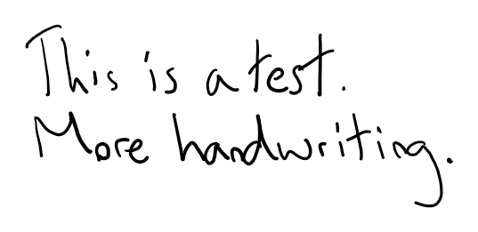

<<Test another.md>>

